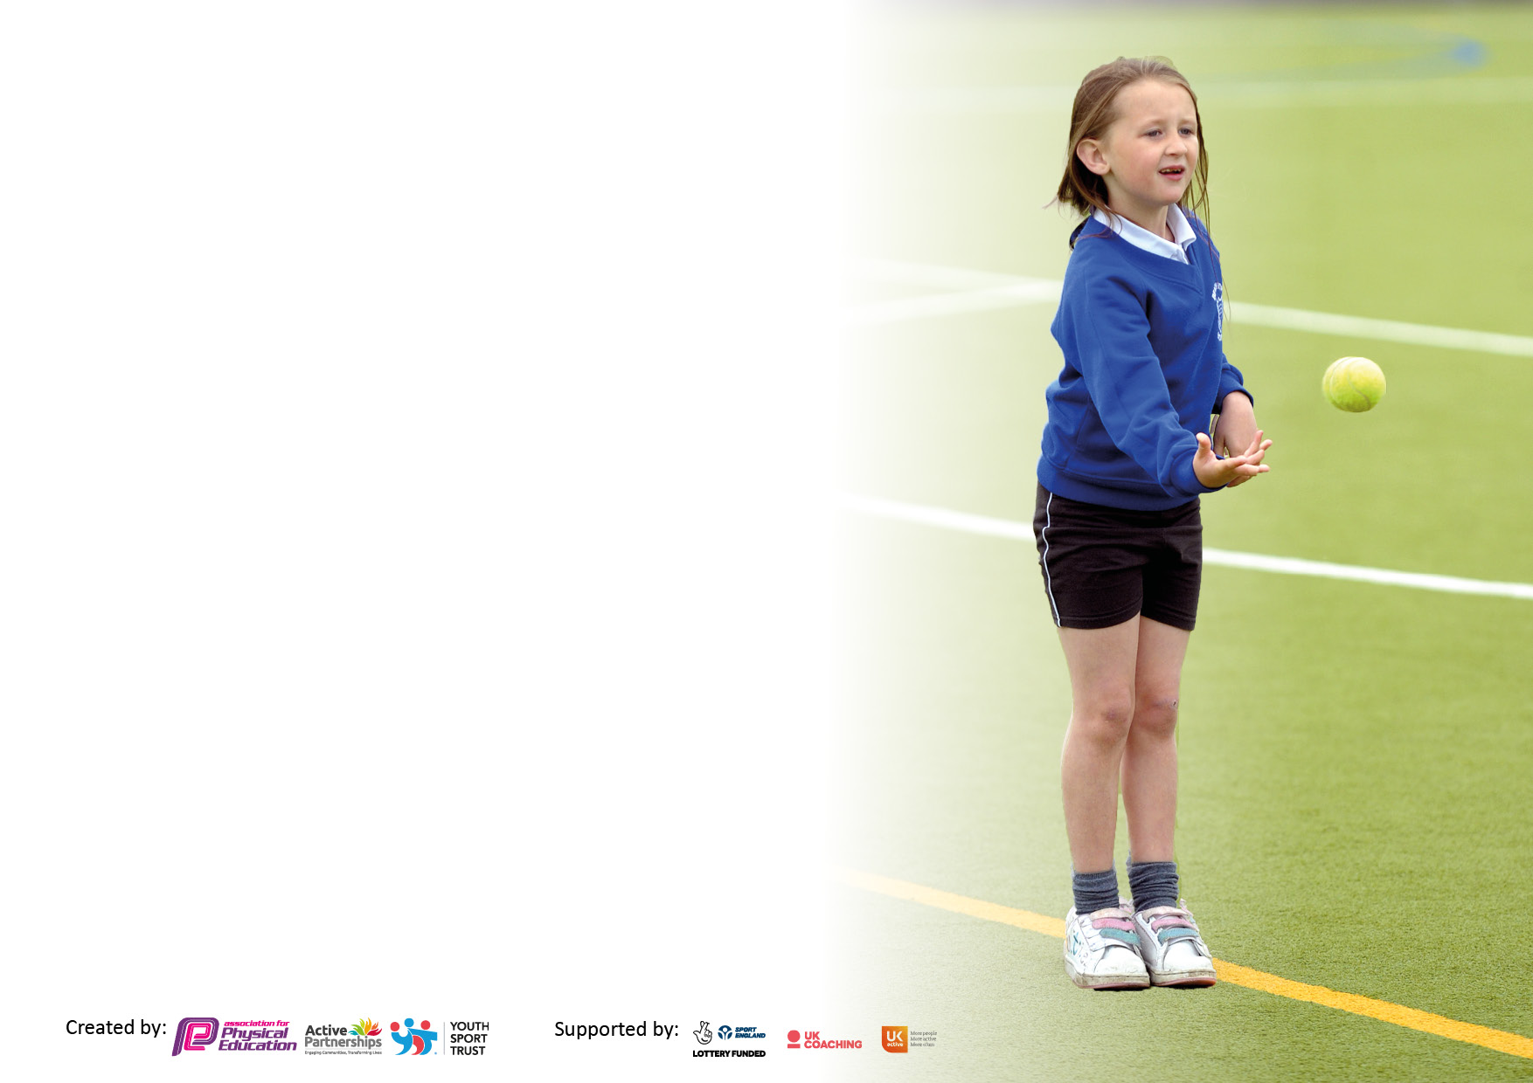

It is important that your grant is used effectively and based on school need. The Education Inspection Framework makes clear there will be a focus on **‘whether leaders and those responsible for governors all understand their respective roles and perform these in a way that enhances the effectiveness of the school’**.

Under the Quality of Education Ofsted inspectors consider:

**Intent** - Curriculum design, coverage and appropriateness

**Implementation** - Curriculum delivery, Teaching (pedagogy) and Assessment

**Impact** - Attainment and progress

To assist schools with common transferable language this template has been developed to utilise the same three headings which should make your plans easily transferable between working documents.

Schools must use the funding to make **additional and sustainable** improvements to the quality of Physical Education, School Sport and Physical Activity (PESSPA) they offer. This means that you should use the Primary PE and sport premium to:

* Develop or add to the PESSPA activities that your school already offer
* Build capacity and capability within the school to ensure that improvements made now will benefit pupils joining the school in future years
* The Primary PE and sport premium should not be used to fund capital spend projects; the school’s budget should fund these.

Pleasevisitgov.ukfortherevisedDfEguidanceincludingthe5keyindicatorsacrosswhichschoolsshoulddemonstrate animprovement.Thisdocumentwillhelpyoutoreviewyourprovisionandtoreportyourspend.DfEencouragesschools to use this template as an effective way of meeting the reporting requirements of the Primary PE and Sport Premium.

We recommend you start by reflecting on the impact of current provision and reviewing the previous spend.

Schools are required to publish details of how they spend this funding, including any under-spend from 2021/2022, as well as on the impact it has on pupils’ PE and sport participation and attainment. **All funding must be spent by 31st July 2023.**

We recommend regularly updating the table and publishing it on your website throughout the year. This evidences your ongoing self-evaluation of how you are using the funding to secure maximum, sustainable impact. Final copy must be posted on your website by the end of the academic year and no later than the 31st July 2023. To see an example of how to complete the table please click HERE.

**Details with regard to funding**

Please complete the table below.

|  |  |
| --- | --- |
| Total amount carried over from 2021/22 | £ |
| Total amount allocated for 2021/22 | £19,223 |
| How much (if any) do you intend to carry over from this total fund into 2022/23? | £4,996 |
| Total amount allocated for 2022/23 | £19,223 |
| Total amount of funding for 2023/23. To be spent and reported on by 31st July 2023. | £ 24,219 (£24,664.55 spent as of 10th July) |

**Swimming Data**

Please report on your Swimming Data below.

|  |  |
| --- | --- |
| Meeting national curriculum requirements for swimming and water safety.  N.B. Complete this section to your best ability. For example you might have practised safe self-rescue techniques on dry land which you can then transfer to the pool when school swimming restarts.  **Due to exceptional circumstances priority should be given to ensuring that pupils can perform safe self rescue even if they do not fully meet the first two requirements of the NC programme of study** |  |
| What percentage of your current Year 6 cohort swim competently, confidently and proficiently over a distance of at least 25 metres?  **N.B.** Even though your pupils may swim in another year please report on their attainment on leaving primary school at the end of the summer term 2022.  Please see note above | 45% |
| What percentage of your current Year 6 cohort use a range of strokes effectively [for example, front crawl, backstroke and breaststroke]?  Please see note above | 50% |
| **What percentage of your current Year 6 cohort perform safe self-rescue in different water-based situations?** | 92% |
| Schools can choose to use the Primary PE and sport premium to provide additional provision for swimming but this must be for activity **over and above** the national curriculum requirements. Have you used it in this way? | No |

**Action Plan and Budget Tracking**

Capture your intended annual spend against the 5 key indicators. Clarify the success criteria and evidence of impact that you intend to measure to evaluate for pupils today and for the future.

|  |  |  |  |  |
| --- | --- | --- | --- | --- |
| **Academic Year:** 2022/23 | **Total fund allocated: £24,219** | **Date Updated: 10/7/23** | |  |
| **Key indicator 1:** The engagement of all pupils in regular physical activity – Chief Medical Officers guidelines recommend that primary school pupils undertake at least 30 minutes of physical activity a day in school | | | | Percentage of total allocation: |
| £8542.05 34.6% |
| **Intent** | **Implementation** | | **Impact** |  |
| Your school focus should be clear what you want the pupils to know and be able to do and about  what they need to learn and to  consolidate through practice: | Make sure your actions to achieve are linked to your intentions: | Funding allocated: | Evidence of impact: what do pupils now know and what can they now do? What has changed?: | Sustainability and suggested next steps: |
| Employment of full-time playleader (N.C) to encourage, facilitate and supervise active lunchtime activities.  Promotion of active lunchtime activities to be continued to be facilitated and led by Playleaders. Every pupil in school will have access to quality equipment and activities every day.  Barriers to facilitate more playground zones/games areas. Feedback from playleader and pupil voice surveys suggest that designated zones on the yard would make playing games easier without interruption from pupils running through or equipment rolling through game areas.  To facilitate more active maths and cross curricular maths/PE links where appropriate.  Annual hire of package and equipment of ‘Now Press Play’-an active literacy tool promoting physical movement in English lessons via audio experiences. | N.C to work each lunchtime Monday-Friday. A small team of playleaders will be selected from Y3-6 to facilitate activities and develop leaderships skills.  N.C to continue organising Playleaders and keep track of equipment needed to facilitate quality lunchtime sessions. Coordinator to compile list of equipment needed.  N.C and PE Lead to discuss which type of barrier would suit our playground space best. PE Lead and B.M to order for Spring 2023. Behaviour to be monitored to see if issues decrease due to a clearer playground layout.  Maths Lead and PE Lead to discuss possible links between subjects. The discrete teaching of times tables is due to be a focus this year and metre sticks for measuring in PE (e.g. for athletic activities such as long jump) that also function as counting sticks would serve both purposes. As of 12/12/22, all teachers have been asked to teach times tables in class in short, discrete sessions, which can be done actively in the classroom with the counting sticks as a visual aid.  J.R and A.S to organise a free trial in the Autumn term before purchasing. Zoom call to talk place on 17/7/22 to facilitate.  Staff training included. Class teachers to plan for regular use of the tool each term. | £3321  £879.06 for replacement/additional equipment/activities  £1699.99 (21 pk)  £96  £2546. | Observation of playground at lunchtimes suggests a large % of pupils from all year groups are engaged in active play.  Behaviour issues have decreased and first aid incidents are less due to less collisions during running/organised games.  Opportunities for short daily active maths times tables sessions have increased.  Staff surveys report staff and pupils’ enjoyment and value from NPP resources. | To continue next year.  To be reviewed Spring 2024. |
| **Key indicator 2:** The profile of PESSPA being raised across the school as a tool for whole school improvement | | | | Percentage of total allocation: |
| £ 1573.10 6.4% |
| **Intent** | **Implementation** | | **Impact** |  |
| Your school focus should be clear what you want the pupils to know and be able to do and about  what they need to learn and to  consolidate through practice: | Make sure your actions to achieve are linked to your intentions: | Funding allocated: | Evidence of impact: what do pupils now know and what can they now do? What has changed?: | Sustainability and suggested next steps: |
| Whole school celebration of School Sports Week 2023 with aims of:   * experience new activities with an understanding of inclusion in sport * experience being part of a team and understand your contribution to it * demonstrate sportsmanship * have fun and enjoy yourselves!   Purchase of class set of new Granby PE tops for pupils to wear when representing the school at events/festivals/competitions. | PE Lead to organise a timetable for the week with provider.  Paralympic sports/wheelchair basketball sessions booked through Express Coaching Services  PE Lead and BM to discuss purchase through Giraffe Workwear in Autumn 2. | £1100  £473.10 | Following sessions and discussions in classrooms around the Paralympic Games and athletes with disabilities, pupils report feeling much more aware and understanding of the skills, techniques and determination needed to compete. |  |

|  |  |  |  |  |
| --- | --- | --- | --- | --- |
| **Key indicator 3:** Increased confidence, knowledge and skills of all staff in teaching PE and sport | | | | Percentage of total allocation: |
| £5649.40 22.9% |
| **Intent** | **Implementation** | | **Impact** |  |
| Your school focus should be clear | Make sure your actions to | Funding | Evidence of impact: what do | Sustainability and suggested |
| what you want the pupils to know | achieve are linked to your | allocated: | pupils now know and what | next steps: |
| and be able to do and about | intentions: |  | can they now do? What has |  |
| what they need to learn and to |  |  | changed?: |  |
| consolidate through practice: |  |  |  |  |
| Staff to feel confident in areas they identify for CPD.  Planning and assessment app-based tool to be renewed. Feedback from staff so far has indicated that this tool is much more convenient, easy to follow and provides good quality lesson content. | PE Lead to issue staff surveys in Autumn and liaise with ESSP regarding CPD opportunities.  Cricket CPD booked for January 2023.  Emails to be sent to remind staff to seek advice on app use if needed and new staff introduced via demo from PE Lead.  Yearly planning done by PE Lead (drag and drop style) ready for teachers to access their own set of plans. | £0  £799  Replacement staff iPads to facilitate use of assessment and planning app: £4,850.40 | Staff report feeling more confident in warm up activities and how to vary the equipment offered to pupils during lessons to suit their abilities.  A wide range of activities have continued to be available to all year groups across the terms. Pupils report enjoying trying out new sports and activities as they progress through the school. PE Lead able to track skills and knowledge progression over units and over time. | Swimming training and OAA training identified for future CPD opportunities. |
| **Key indicator 4:** Broader experience of a range of sports and activities offered to all pupils | | | | Percentage of total allocation: |
| £10,000 40.5% |
| **Intent** | **Implementation** | | **Impact** |  |
| Your school focus should be clear | Make sure your actions to | Funding | Evidence of impact: what do | Sustainability and suggested |
| what you want the pupils to know | achieve are linked to your | allocated: | pupils now know and what | next steps: |
| and be able to do and about | intentions: |  | can they now do? What has |  |
| what they need to learn and to |  |  | changed?: |  |
| consolidate through practice: |  |  |  |  |
| Member of staff from ESSP employed to work at Granby four afternoons a week to engage pupils in after school clubs.  All pupils in Y4,5 and 6 offered Level 1 and 2 Bikeability sessions with a member of staff from ESSP as part of our Silver package.  Whole school celebration of School Sports Week 2023 with aims of:   * experience new activities with an understanding of inclusion in sport * experience being part of a team and understand your contribution to it * demonstrate sportsmanship * have fun and enjoy yourselves!   Other Whole School enrichment day to be booked to expand pupils’ experience and access to new and exciting sports. | PE Lead to monitor attendance numbers across all groups. Clubs to be chosen based on target groups across the year (e.g. PP, SEND, disengaged, low confidence)  PE Lead to liase with ESSP to arrange a timetable for delivery.  Paralympic sports/wheelchair basketball sessions booked through Express Coaching Services  Spring 1 meeting with PE Lead and SH Active Sports to discuss possible enrichment days.  Zorbing and Laser Tag selected and classes assigned to one of the activities throughout the day on Friday 5th March.  Quidditch two days booked for June 2023 | £3600  ESSP Silver package includes bike ability sessions-£2200  £1100  £350 (subsidised from free funded hours)  Quidditch event: £1600  Minibus hire to get to Physical Literacy event: £350  Supply cover for staff attending events with pupils: £800 | 45% of pupils have engaged with an after-school club this academic year, up from previous year and the highest since before lockdown. 46.2%=SEND and 41.7%=PP  Good level of participation across eligible year groups. Pupils can confidently and safely ride on the roads and report enjoying their sessions and learning new skills.  Following sessions and discussions in classrooms around the Paralympic Games and athletes with disabilities, pupils report feeling much more aware and understanding of the skills, techniques and determination needed to compete.  A real buzz was felt around school during our enrichment day and following this. Previously disengaged pupils spoke of how much they enjoyed their activity and across school, pupils were showing interest in attending the resulting after school clubs. | Aim to have above 50% of pupils engaging in a club next academic year. Rotation of clubs on offer to continue and target groups identified in a similar manner to this year.  To continue through ESSP affiliation package next year.  New PE Lead to consider booking again for next year’s School Sports Week with a different inclusive focus for the sports sessions.  Quidditch to be booked again for June 2024 to set the challenge of Gryffindor being beaten this time!  Unfortunately, take up of the paid after school clubs from SH Active Sports was low.  PE Lead to discuss with SH Active Sports what can be booked for continuous after school and regular enrichment provision next academic year in the form of days/afternoons. |

|  |  |  |  |  |
| --- | --- | --- | --- | --- |
| **Key indicator 5:** Increased participation in competitive sport | | | | Percentage of total allocation: |
| £3800 15.4% |
| **Intent** | **Implementation** | | **Impact** |  |
| Your school focus should be clear | Make sure your actions to | Funding | Evidence of impact: what do | Sustainability and suggested |
| what you want the pupils to know | achieve are linked to your | allocated: | pupils now know and what | next steps: |
| and be able to do and about | intentions: |  | can they now do? What has |  |
| what they need to learn and to |  |  | changed?: |  |
| consolidate through practice: |  |  |  |  |
| Continue to offer a wider range of competitive opportunities through our affiliation with the ESSP. Pupils will have access to competitive sporting activities that will broaden their experiences.  Competitive opportunities will be available to every pupil through intra-class/intra-year group/intra-school competitions. | PE Lead to book on to events. (July 2022)  Teachers asked to end a PE unit where relevant with an intra-year group competition. (E.g. Y4 have experienced hockey and dodgeball in this way).  Whole School Sports Day to result in a winning house.  Intra-school quidditch event booked for June 2023. | ESSP Silver Package: £2200  Quidditch event: £1600 | 32.9% of pupils participated in an extra-curricular event/competition. 25.4%=PP and 24%=SEND  Year 4 had the lowest % of pupils from their year group participating. | A higher number of events to be booked via the ESSP for 2023-24. Focus on Y4 opportunities so this can increase to match other year groups. |

|  |  |
| --- | --- |
| Signed off by | |
| Head Teacher: |  |
| Date: |  |
| Subject Leader: | J. Robinson |
| Date: | 10/7/23 |
| Governor: |  |
| Date: |  |