# E:\Users\simon.roche\AppData\Local\Microsoft\Windows\Temporary Internet Files\Content.Word\Evidencing the Impact of the Primary PE and Sport Premium Template 2019 7.3 Images_Page_1.jpg

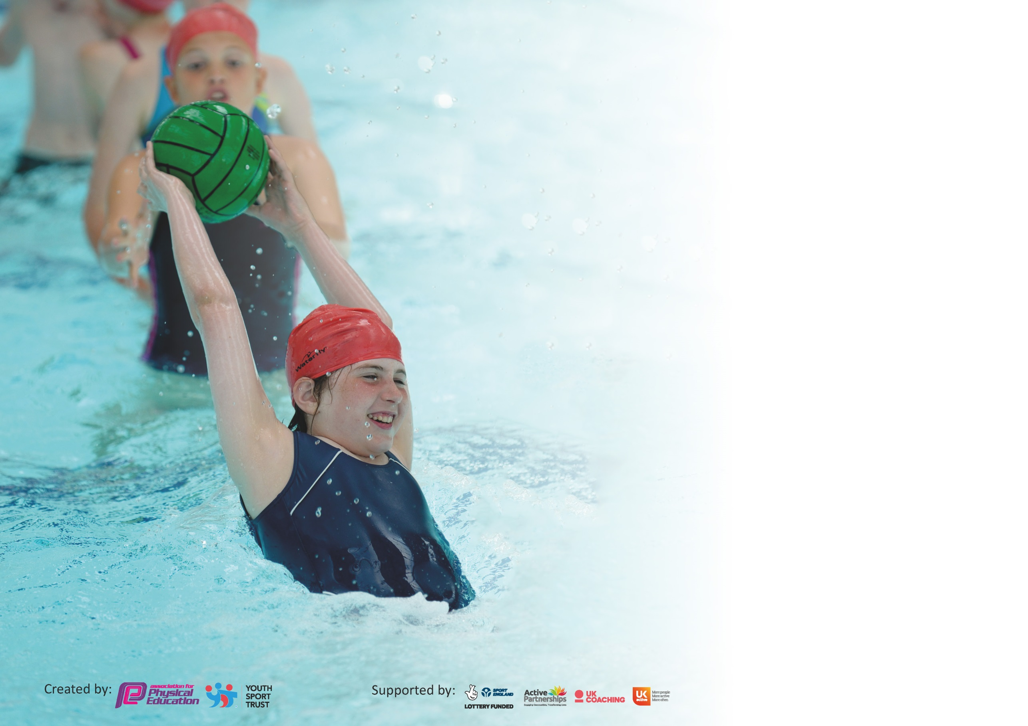

It is important that your grant is used effectively and based on school need. The [Education Inspection Framework](https://assets.publishing.service.gov.uk/government/uploads/system/uploads/attachment_data/file/843108/School_inspection_handbook_-_section_5.pdf) (Ofsted 2019 p64) makes clear there will be a focus on **‘whether leaders and those responsible for governors all understand their respective roles and perform these in a way that enhances the effectiveness of the school’**.

Under the [Quality of Education criteria](https://assets.publishing.service.gov.uk/government/uploads/system/uploads/attachment_data/file/843108/School_inspection_handbook_-_section_5.pdf) (p41) inspectors consider the extent to which schools can articulate their curriculum (INTENT), construct their curriculum (IMPLEMENTATION) and demonstrate the outcomes which result (IMPACT).

To assist schools with common transferable language this template has been developed to utilise the same three headings which should make your plans easily transferable between working documents.

Schools must use the funding to make **additional and sustainable** improvements to the quality of Physical Education, School Sport and Physical Activity (PESSPA) they offer. This means that you should

use the Primary PE and Sport Premium to:

* Develop or add to the PESSPA activities that your school already offer
* Build capacity and capability within the school to ensure that improvements made now will benefit pupils joining the school in future years

Please visit [gov.uk](https://www.gov.uk/guidance/pe-and-sport-premium-for-primary-schools) for the revised DfE guidance including the 5 key indicators across which schools should demonstrate an improvement. This document will help you to review your provision and to report your spend. DfE encourages schools to use this template as an effective way of meeting the reporting requirements of the Primary PE and Sport Premium.

We recommend you start by reflecting on the impact of current provision and reviewing the previous spend.

Schools are required to [publish details](https://www.gov.uk/guidance/what-maintained-schools-must-publish-online#pe-and-sport-premium-for-primary-schools) of how they spend this funding as well as on the impact it has on pupils’ PE and sport participation and attainment by the end of the summer term or by **31st July 2020** at the latest.

We recommend regularly updating the table and publishing it on your website throughout the year. This evidences your ongoing self-evaluation of how you are using the funding to secure maximum, sustainable impact. Final copy must be posted on your website by the end of the academic year and no later than the 31st July 2020. To see an example of how to complete the table please click [HERE](http://www.afpe.org.uk/physical-education/wp-content/uploads/afPE-Example-Template-Indicator-2018-Final.pdf).

Support for review and reflection - considering the 5 key indicators from DfE, what development needs are a priority for your setting and your pupils now and why? Use the space below to reflect on previous spend and key achievements and areas for development.

|  |  |
| --- | --- |
| Key achievements to date until July 2020: | Areas for further improvement and baseline evidence of need: |
| * KEY INDICATOR 1: PRE\_COVID-19: Daily Mile initiative introduced across year groups to boost daily minutes spent being active. All classrooms supplied with spare kit so pupils do not miss out on their PE lessons due to lack of suitable clothing. The number of pupils attending events was again on the rise. Pupils were taking part in inter school festivals and competitions every term through Erewash School Sports Partnership (ESSP). Bikeability runs successfully every year with average uptake. The attendance numbers for our after school clubs were increasing with a continued increased range of activities on offer. Coordinator was conducting inclusive sporting activities during Granby Academy each Friday afternoon. * KEY INDICATOR 2: School is now on Twitter with a general whole school page. Relevant details will be sent to HT to promote events and activities taking place around school sport and PE throughout the academic year. * KEY INDICATOR 3: School continues to invest in the Primary PE Passport app, meaning all children will access regular P.E education throughout KS2 which can be delivered confidently by staff members. Plans include differentiation for all abilities. * KEY INDICATOR 4: School experienced a Quidditch taster day and tournament in the academic year 2018-19 to introduce a new activity and widen the range of sports/activities our pupils could access. Response was very positive from pupils and adults. This had been booked in again for summer 2020 but was postponed until 2021. * KEY INDIACTOR 5: In the 2018-19 Sainsbury’s Survey, results have shown an increasing number of children are competing in both inter and intra-school competitions and after school club attendance was also improving. | * KEY INDICATIOR 1: All classes need to re-engage pupils with the Daily Mile initiative during this academic year once yard space allows it and year group bubbles are created. After school clubs will be reintroduced when it is deemed safe to do so by SLT. * KEY INDICATOR 2: Lunchtime challenges at the end of a term to continue once COVID-19 restrictions allow with the portable music system being used on the yard: behaviour/detention issues to continue to be monitored. Coordinator to discuss possibility of having a dedicated PE Twitter page run by coordinator to promote sport and PE from across school. * KEY INDICATOR 3: We will be investing in the Silver ESSP package this year in order to access in-house and virtual competitions for all pupils. Virtual CPD opportunities through the ESSP offered to all staff. * KEY INDICATOR 4: PE coordinator will be looking at booking further taster days for the whole school to experience. After school clubs will be reintroduced when it is deemed safe to do so by SLT. * KEY INDIACTOR 5: Last year’s opportunities were cut short for pupils so to re-boost this incline in numbers, school will be re-investing in the Silver ESSP package and school will continue to enter a wide range of sports to ensure opportunities appeal to as many pupils as possible, although this will be done virtually within classes until further notice. Details of competitions to be sent out by coordinator to all teaching staff. Extra opportunities for intra-year group and intra-school competitions will also be available this academic year through our chosen taster activities (e.g. Quidditch) and staff will be asked again in their year groups to arrange end-of-unit competitions. |

|  |  |
| --- | --- |
| **Meeting national curriculum requirements for swimming and water safety.** |  |
| What percentage of your current Year 6 cohort swim competently, confidently and proficiently over a distance of at least 25 metres?  **N.B.** Even though your pupils may swim in another year please report on their attainment on leaving  primary school at the end of the summer term 2020. | N/A-Covid |
| What percentage of your current Year 6 cohort use a range of strokes effectively [for example, front crawl, backstroke and breaststroke]? | N/A-Covid |
| What percentage of your current Year 6 cohort perform safe self-rescue in different water-based situations? | N/A-Covid |
| Schools can choose to use the Primary PE and Sport Premium to provide additional provision for swimming but this must be for activity **over and above** the national curriculum requirements. Have you used it in this way? | **Yes**/No-paid but no access to the top up sessions due to COVID-19 closures. |

**Action Plan and Budget Tracking**

Capture your intended annual spend against the 5 key indicators. Clarify the success criteria and evidence of impact that you intend to measure to evaluate for pupils today and for the future.

|  |  |  |  |  |
| --- | --- | --- | --- | --- |
| **Academic Year:** 2020/21 | **Total fund allocated:** £19223 (+ £5843 carried forward from 2019-20= £25066) | **Date Updated: 29/3/2022** | |  |
| **Key indicator 1:** The engagement of all pupils in regular physical activity – Chief Medical Officer guidelines recommend that primary school pupils undertake at least 30 minutes of physical activity a day in school | | | | Percentage of total allocation: |
| £8304.12 – 33.1% |
| **Intent** | **Implementation** | | **Impact** |  |
| **Your school focus should be clear what you want the pupils to know and be able to do and about**  **what they need to learn and to**  **consolidate through practice:** | **Make sure your actions to achieve are linked to your intentions:** | **Funding allocated:** | **Evidence of impact: what do pupils now know and what can they now do? What has changed?:** | **Sustainability and suggested next steps:** |
| Taster days to be booked for whole school to access. Pupils will be able to experience new sporting activities that they may wish to pursue going forward.  Speed stacking sets to be ordered. This national, record-setting activity will be used in classrooms on days when PE lessons can not go ahead due to poor weather. This will allow pupils to still access a new activity which improves hand-eye coordination, gross and fine motor skills and competitive skills, even when their standard PE lesson is disrupted or cancelled due to weather.  Review heatmap on <https://www.activeschoolplanner.org/> to highlight areas of inactivity throughout the school day in December 2020.  Employment of full-time playleader (N.C) to encourage, facilitate and supervise active lunchtime activities.  Promotion of active lunchtime activities to be continued to be facilitated and led by Playleaders. Every pupil in school will have access to quality equipment and activities every day. | Quidditch re-booked for July 2021.  Order speed stacking set-March 2020. Order chased in September 2020. Delivered week of October half term.  Staff meeting time required to demonstrate to staff and give them time to try it out before delivering it in classes. Delivered to 6 teachers on 12/11/2020  Video resources available online to support classes too.  To be completed after term 1 of 2020-21 academic year to highlight areas for improvement going forward. Coordinator to source resources/ideas to boost physical movement during lessons and send to staff where appropriate.  N.C to work each lunchtime Monday-Friday. A small team of playleaders will be selected from Y3-6 to help.  N.C to continue organising Playleaders and keep track of equipment needed to facilitate quality lunchtime sessions. Coordinator to compile list of equipment needed. | Quidditch: £1200  £1616.67  FREE  £3214  Installation of playground activity track-£2245.50  Limbo play set-£27.95 | Staff reported an enjoyable day had by all. Pupils introduced to a new sport and practice of multiple skills. All pupils engaged including pupils who previously held a disinterest in sport.  Competitions now ongoing in classes. Fine and gross motor skills being developed.  Positive impact on active minutes for all pupils. Lunchtime observations show a large percentage of pupils on the yard during lunchtimes are engaged in physical activity in a positive way. | New taster days to be looked into by PE coordinator next year to expand pupils’ experiences further.  PE coordinator to introduce speed-stacking to new staff members during the next academic year to ensure all classes are accessing the same provision. |
| **Key indicator 2:** The profile of PESSPA being raised across the school as a tool for whole school improvement | | | | Percentage of total allocation: |
| £0-0% |
| **Intent** | **Implementation** | | **Impact** |  |
| **Your school focus should be clear what you want the pupils to know and be able to do and about**  **what they need to learn and to**  **consolidate through practice:** | **Make sure your actions to achieve are linked to your intentions:** | **Funding allocated:** | **Evidence of impact: what do pupils now know and what can they now do? What has changed?:** | **Sustainability and suggested next steps:** |
| Updates regarding school sport successes and engagement to be sent out on Twitter by HT when relevant and also added to school website. Results from parent survey indicate that few parents use the school website and would like to see more on Twitter or on newsletters. | Co-ordinator to request access to a dedicated school PE Twitter account to ensure regular updates to raise the profile of Granby’s school sport. | FREE | Low impact-a dedicated PE and school sports Granby account would mean more regular and timely updates are sent and shared with other local schools in our cluster. | PE lead to discuss next steps with HT. |

|  |  |  |  |  |
| --- | --- | --- | --- | --- |
| **Key indicator 3:** Increased confidence, knowledge and skills of all staff in teaching PE and sport | | | | Percentage of total allocation: |
| £599 – 2.4% |
| **Intent** | **Implementation** | | **Impact** |  |
| **Your school focus should be clear** | **Make sure your actions to** | **Funding** | **Evidence of impact: what do** | **Sustainability and suggested** |
| **what you want the pupils to know** | **achieve are linked to your** | **allocated:** | **pupils now know and what** | **next steps:** |
| **and be able to do and about** | **intentions:** |  | **can they now do? What has** |  |
| **what they need to learn and to** |  |  | **changed?:** |  |
| **consolidate through practice:** |  |  |  |  |
| Planning and assessment app-based tool to be renewed. Feedback from staff so far has indicated that this tool is much more convenient.  Staff in Y4 and Y5 have highlighted the need for swimming training to boost confidence and quality of these sessions. Last year’s course was postponed due to COVID-19.  PE Passport | Emails to be sent to remind staff to seek advice on app use if needed.  Yearly planning done by PE coordinator (drag and drop style) ready for teachers to access their own set of plans.  Places on course to be booked by office manager when COVID-19-19 regulations allow. | £599  (Postponed to 2022) | A wider range of activities are now available to all year groups across the terms. Lacrosse has been enjoyed by Y6 as a new sport at Granby. | To continue.  PE lead and office manager to look into courses offered next year. |
| **Key indicator 4:** Broader experience of a range of sports and activities offered to all pupils | | | | Percentage of total allocation: |
| £8776.05 – 35% |
| **Intent** | **Implementation** | | **Impact** |  |
| **Your school focus should be clear** | **Make sure your actions to** | **Funding** | **Evidence of impact: what do** | **Sustainability and suggested** |
| **what you want the pupils to know** | **achieve are linked to your** | **allocated:** | **pupils now know and what** | **next steps:** |
| **and be able to do and about** | **intentions:** |  | **can they now do? What has** |  |
| **what they need to learn and to** |  |  | **changed?:** |  |
| **consolidate through practice:** |  |  |  |  |
| Member of staff from ESSP to work at Granby two afternoons a week, to engage classes in the virtual competitions offered to school.  Invest in extra swimming sessions for Year 6 to ensure as many pupils as possible leave primary school with the necessary skills and experiences in swimming.  Quidditch taster sessions to be booked for whole school to increase experience of different non-traditional sports. Y3 and 4 pupils will be able to experience Quidditch for the first time.  Speed stacking sets to be ordered. This national, record-setting activity will be used in classrooms on days when PE lessons cannot go ahead due to poor weather. This will allow pupils to still access a new activity which improves hand-eye coordination, gross and fine motor skills and competitive skills, even when their standard PE lesson is disrupted or cancelled.  All pupils in Y4,5 and 6 offered Level 1 and 2 Bikeability sessions with a member of staff from ESSP as part of our Silver package. Spare bikes and helmets borrowed from staff member and ESSP to allow pupils without the necessary equipment to participate.  Three spare bikes and helmets purchased to be kept in school to facilitate this in years to come.  Y6 pupils to take part in a teambuilding and problem-solving workshop. | J.J from ESSP to attend Granby twice a week. In the event of lockdown, J.J would still provide home work out and activity videos for all pupils in school and at home to access.  Extra sessions to be offered to those not yet reaching the government recommendation in Summer terms.  Quidditch re-booked for July 2021.  Order speed stacking set-March 2020. Order chased in September 2020. Delivered week of October half term.  Staff meeting time required to demonstrate to staff and give them time to try it out before delivering it in classes. Delivered to 6 teachers on 12/11/2020  Video resources available online to support classes too.  Contact stores such as Sports Direct/Halfords, etc to see if they can offer a school discount-October 2020.  Contact The Problem Solving Company to book-Sept 20. | £2759.38  (Postponed to 2022)  Quidditch: £1200  £1616.67  ESSP Silver Package: £2000  Bikes and helmets £ (postponed to 2022)  Whole day for three classes: £1200 | Positive impact on active minutes for all pupils. The number of pupils accessing competitions is beginning to increase following the impact from Covid-19.  Staff reported an enjoyable day had by all. Pupils introduced to a new sport and practice of multiple skills. All pupils engaged including pupils who previously held a disinterest in sport.  Competitions now ongoing in classes. Fine and gross motor skills being developed.  Higher than average number of pupils participated in Bikeability this year. Pupils can confidently and safely ride on the roads.  Staff reported an improvement in the team spirit of classes following this experience and our Y6s reported an enjoyable day with new skills learnt, particularly in the art of communication! | In person competitions to recommence next year.  New taster days to be looked into by PE coordinator next year to expand pupils’ experiences further.  PE coordinator to introduce speed-stacking to new staff members during the next academic year to ensure all classes are accessing the same provision.  To continue to be promoted to all pupils and parents next year along with the purchasing of bikes and equipment to facilitate participation of those without their own. |

|  |  |  |  |  |
| --- | --- | --- | --- | --- |
| **Key indicator 5:** Increased participation in competitive sport | | | | Percentage of total allocation: |
| £4816.67 – 19.2% |
| **Intent** | **Implementation** | | **Impact** |  |
| **Your school focus should be clear** | **Make sure your actions to** | **Funding** | **Evidence of impact: what do** | **Sustainability and suggested** |
| **what you want the pupils to know** | **achieve are linked to your** | **allocated:** | **pupils now know and what** | **next steps:** |
| **and be able to do and about** | **intentions:** |  | **can they now do? What has** |  |
| **what they need to learn and to** |  |  | **changed?:** |  |
| **consolidate through practice:** |  |  |  |  |
| Continue to offer a wider range of competitive opportunities through our affiliation with the ESSP. Every pupil will have access to competitive sporting activities that will broaden their experiences. To be done virtually this year.  Year groups to arrange intra-cohort competitions at the end of a unit of work where appropriate, e.g. at the end of a hockey unit, classes play one another for points. Will need to be done within class bubbles until COVID-19 regulations are eased.  Quidditch taster sessions to be booked for whole school to increase experience of different non-traditional sports. School house competition conducted over the course of the sessions.  Speed stacking sets to be ordered. This national, record-setting activity will be used in classrooms on days when PE lessons can not go ahead due to poor weather. This will allow pupils to still access a new activity which improves hand-eye coordination, gross and fine motor skills and competitive skills, even when their standard PE lesson is disrupted or cancelled. | Details of all competitions made available to Granby to be sent to all teaching staff.  Coordinator to email staff to remind of this in Autumn term. To be planned within year group teams.  Quidditch re-booked for July 2021.  Order speed stacking set-March 2020. Order chased in September 2020. Delivered week of October half term.  Staff meeting time required to demonstrate to staff and give them time to try it out before delivering it in classes. Delivered to 6 teachers on 12/11/2020  Video resources available online to support classes too.  Coordinator to set up a whole school record document. Shared with staff Nov 2020. Staff to add in top scorers from their class for each challenge. Ongoing whole-school competition. | ESSP Silver Package: £2000  FREE  Quidditch: £1200  £1616.67 | Virtual competitions only were entered this year meaning whole classes at a time could participate resulting in increasing numbers of pupils participating.  Low impact-not all classes engaged with this due to timetable and space restrictions.  Staff reported an enjoyable day had by all. Pupils introduced to a new sport and practice of multiple skills. All pupils engaged including pupils who previously held a disinterest in sport.  Competitions now ongoing in classes. Fine and gross motor skills being developed. | In person competitions to recommence next year.  PE lead to promote intra-class competitions at staff meeting next year.  New taster days to be looked into by PE coordinator next year to expand pupils’ experiences further.  PE coordinator to introduce speed-stacking to new staff members during the next academic year to ensure all classes are accessing the same provision. |

|  |  |
| --- | --- |
| Total spend for 2020-2021 academic year: £14862.50  Totals in black font reflect spending before April 2020.  Totals in orange font reflect spending after start of new tax year April 2021. | |
| Signed off by | |
| Head Teacher: |  |
| Date: |  |
| Subject Leader: | Miss J Robinson |
| Date: | 8/2/2021-revisited 29/3/2022 |
| Governor: |  |
| Date: |  |