

Schools must use the funding to make **additional and sustainable** improvements to the quality of PE and sport they offer. This means that you should use the Primary PE and Sport Premium to:

* develop or add to the PE and sport activities that your school already offers
* 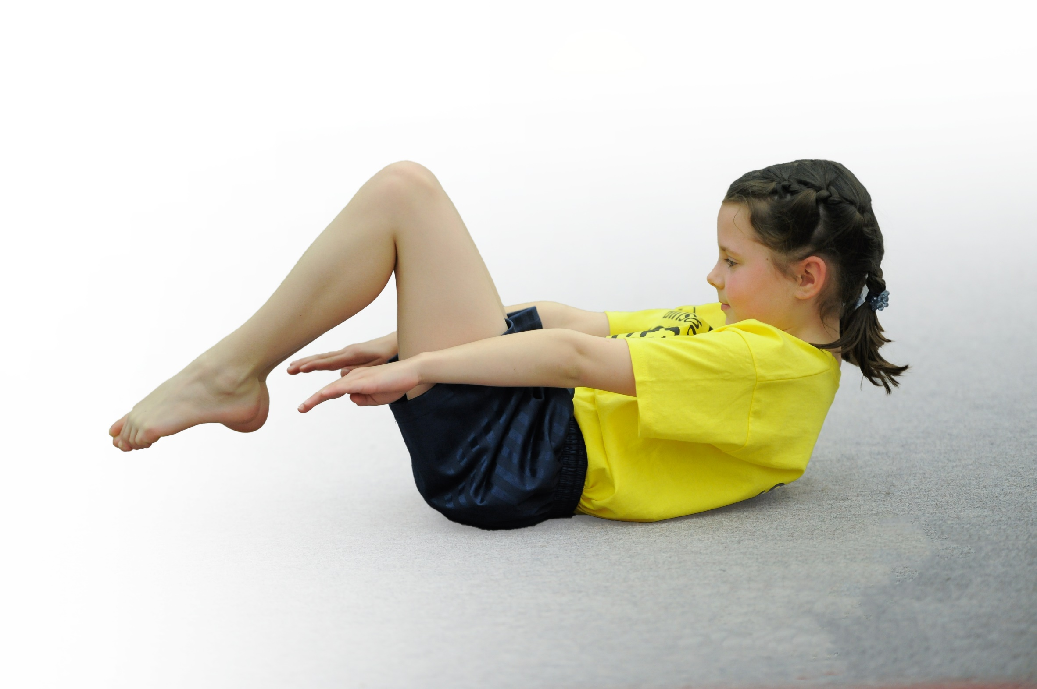build capacity and capability within the school to ensure that improvements made now will benefit pupils joining the school in future years

Please visit [gov.uk](https://www.gov.uk/guidance/pe-and-sport-premium-for-primary-schools) for the revised DfE guidance including the 5 key indicators across which schools should demonstrate an improvement. This document will help you to review your provision and to report your spend. DfE encourages schools to use this template as an effective way of meeting the reporting requirements of the Primary PE and Sport Premium.

We recommend you start by reflecting on the impact of current provision and reviewing the previous spend.

Under the [Ofsted Schools Inspection Framework](https://www.gov.uk/government/publications/school-inspection-handbook-from-september-2015), inspectors will assess how effectively leaders use

the Primary PE and Sport Premium and measure its impact on outcomes for pupils, and how effectively [governors](https://www.gov.uk/government/publications/governance-handbook) hold them to account

for this.

Schools are required to [publish details](https://www.gov.uk/guidance/what-maintained-schools-must-publish-online#pe-and-sport-premium-for-primary-schools) of how they spend this funding as well as on the impact it has on pupils’ PE

and sport participation and attainment.

We recommend regularly updating the table and

publishing it on your website as evidence

of your ongoing review into how you are using the money

to secure maximum, sustainable impact. To see an example of how to complete the table please click [HERE](http://www.afpe.org.uk/physical-education/wp-content/uploads/Template-Exemplification.pdf).

Support for review and reflection - considering the 5 key indicators from DfE, what development needs are a priority for your setting and your students now and why? Use the space below to reflect on previous spend, identify current need and priorities for the future.

|  |  |
| --- | --- |
| Key achievements to date: | Areas for further improvement and baseline evidence of need: |
| KEN INDICATOR 1: Daily Mile initiative introduced across year groups to boost daily minutes spent being active. All classrooms supplied with spare kit so pupils do not miss out on their PE lessons due to lack of suitable clothing.  KEY INDICATOR 2: Updated PE noticeboard promotes activities and events taking place in and around school and the Daily Mile has proven popular with children and parents who have stated that it improves concentration and sleep.  KEY INDICATOR 3 and 4: School have purchased a scheme of work with easy to follow session plans for all staff, meaning all children will access regular P.E education throughout KS2 which can be delivered confidently by staff members.  KEY INDIACTOR 5: Over the last three years, Sainsbury’s Survey results have shown an increasing number of children who are competing in both inter and intra-school competitions. | KEY INDICATIOR 1: All classes need to re-engage pupils with the initiative during this academic year. School will be looking at other initiatives available to provide other ways for children to be active at school.  KEY INDICATOR 2: Engagement of all staff is needed to allow the profile of PE and sport to be raised across the whole school. Weekly PACE lessons to be delivered by coordinator during Granby Academy timetable to highlight to pupils the benefits of a healthy and active lifestyle. Also see KI1.  KEY INDICATOR 3 and 4: Our current planning does not provide as in depth differentiation ideas as others available and is often repetitive across year groups. To boost the engagement and enjoyment of all pupils, school will be looking into other schemes which also offer a time-saving assessment scheme.  KEY INDIACTOR 5: to continue this incline, school will be re-investing in the ESSP package and school will continue to enter a wide range of sports to ensure opportunities appeal to as many pupils as possible. |

|  |  |
| --- | --- |
| Meeting national curriculum requirements for swimming and water safety | Please complete all of the below: |
| What percentage of your Year 6 pupils could swim competently, confidently and proficiently over a distance of at least 25 metres when they left your primary school at the end of last academic year? | 80% |
| What percentage of your Year 6 pupils could use a range of strokes effectively [for example, front crawl, backstroke and breaststroke] when they left your primary school at the end of last academic year? | 34% (Aquatic Award 5-7) |
| What percentage of your Year 6 pupils could perform safe self-rescue in different water-based situations when they left your primary school at the end of last academic year? | 34% |
| Schools can choose to use the Primary PE and Sport Premium to provide additional provision for swimming but this must be for activity **over and above** the national curriculum requirements. Have you used it in this way? | **Yes**/~~No~~ |
|  | |

**Action Plan and Budget Tracking**

Capture your intended annual spend against the 5 key indicators. Clarify the success criteria and evidence of impact that you intend to measure to evaluate for students today and for the future.

|  |  |  |  |  |
| --- | --- | --- | --- | --- |
| **Academic Year: 2017/18** | **Total fund allocated: £15,147** | **Date Updated:19/1/18** | |  |
| **Key indicator 1:** The engagement of all pupils in regular physical activity – Chief Medical Officer guidelines recommend that primary school children undertake at least 30 minutes of physical activity a day in school | | | | Percentage of total allocation: |
| 7.43% (£1,124.67) |
| School focus with clarity on intended **impact on pupils**: | Actions to achieve: | Funding allocated: | Evidence and impact: | Sustainability and suggested next steps: |
| All classes to experience a session with ‘Dan the Skipping Man’ to introduce them to a new exercise and skill set which could be used at break/lunchtimes. Class set of ropes also purchased for this purpose.  Continuation of the Daily Mile to encourage pupils to be active for between 10-15 minutes per school day, outside of break and lunch times.  To take part in Sports Relief Daily Challenges to promote physical movement throughout the days involved and raise awareness.  Deliver PACE style lessons to Granby Academy groups to provide pupils with ideas for active playground games.  To install bike/scooter rack as previously outlines in action plans to raise the number of pupils being active on route to school rather than being dropped off in a car.  Mount Cook trip for remaining Y6s who did not go to Whitehall. | Book sessions in September for November dates.  Purchase class set to be delivered on the day.  Remind all staff in first staff meeting of September to timetable this in to new schedule.  Order fundraising pack during Autumn term ready for arrival in January.  Plan sessions to include aspects of healthy eating, getting 60 minutes of activity per day and drinking water.  Check with L.L and K.A what the latest information with this is  S.L to lead January day trip with D.S, alongside other activities throughout the week. | £836.67  FREE  FREE  FREE  Fundraising money from dodgeball, July 2017.  £288 | Quotes published on website on how much pupils enjoyed their time with Dan. Skipping area zoned out on the yard for safe skipping.  More pupils active for an additional 15 minutes a day. However, staff need to be fully supportive of this initiative for it to show impact on wider aspects of school life, e.g. behavior.  Pupils more able to discuss how to adopt healthy strategies into their lives. Are more aware of how much water they should drink, how much activity they should have per day, etc.  All of Y6 are able to access an OAA week, including those who are not attending Whitehall. | School will look at invited Dan back in for a top up session next year to renew the excitement and interest shown.  To continue. Adults to share ideas for engaging children with this, e.g. running the distance to Paris, passports, etc.  Lessons with Miss R (coordinator) to continue with the active minutes focus.  Following the installation in summer 2018, next academic year should see an increase in pupils making use of this mode of transport on their way to and from school.  SLT will need to decide if this is to happen again next year. |
| **Key indicator 2:** The profile of PE and sport being raised across the school as a tool for whole school improvement | | | | Percentage of total allocation: |
| 5.53% (£836.67) |
| School focus with clarity on intended **impact on pupils**: | Actions to achieve: | Funding allocated: | Evidence and impact: | Sustainability and suggested next steps: |
| Celebration of participation and achievement during assembly following an event to encourage all pupils to aspire to this. Results also published on website for parents to access.  School noticeboard kept up to date with relevant sporting events and clubs in the area. All results, details of events and photographs published on the school website on a designated page.  All classes to experience a session with ‘Dan the Skipping Man’ to introduce them to a new exercise and skill set which could be used at break/lunchtimes. Class set of ropes also purchased for this purpose. | Trophies and certificates to be hand out as earnt. Team will be applauded at the front.  Update as required.  Book sessions in September for November dates.  Purchase class set to be delivered on the day. | FREE  FREE  £836.67 | Pupils celebrate together and explain their experiences to peers to encourage more take up on competitive and non-competitive events throughout the year.  Team photos are displayed here and any information about local clubs that may interest our pupils.  Quotes published on website on how much pupils enjoyed their time with Dan. Skipping area zoned out on the yard for safe skipping. Adults on the day commented on how engaged L.M (5T) was with this. Class teacher to explore using this as a tool to integrate him on the yard as a leader or participant. | Next steps-look at moving sports noticeboard to a more prominent area in reception for parents and visitors to see. Current location means few people pass it.  School will look at invited Dan back in for a top up session next year to renew the excitement and interest shown. |

|  |  |  |  |  |
| --- | --- | --- | --- | --- |
| **Key indicator 3:** Increased confidence, knowledge and skills of all staff in teaching PE and sport | | | | Percentage of total allocation: |
| 42.51% (£6439.95) |
| School focus with clarity on intended  **impact on pupils**: | Actions to achieve: | Funding  allocated: | Evidence and impact: | Sustainability and suggested  next steps: |
| To improve progress and enjoyment of PE lessons, one member of staff from each year group will attend an Outstanding PE course with the PE coordinator and feed back to their colleagues.  A new planning and assessment system (iPEP) will also be implemented in Spring 1which more clearly outlines differentiated activities than our current planning does and is supported with images and videos to enable less confident staff to more easily follow the plans and lesson ideas. Assessing pupils against set objectives will also give our pupils a clearer idea of how they are doing and allow staff to tailor next steps.  New storage cupboards installed in the hall to enable staff to easily locate and access a wide range of quality resources held in school. Electric pump purchased for easy use and to ensure equipment is maintained and available when needed.  Release of PE Coordinator to attend PLT meetings 3 x per year. | Book staff on to course in Autumn 1. Supply cover required.  Demo/trial to be shown to coordinator via phone call.  Book staff meeting time to relay this to staff.  Planning to be done by PE coordinator (drag and drop style) ready for teachers to access their own set of plans.  Cupboards installed during October half term.  Dates of meetings included in partnership affiliation package. | SILVER ESSP package-£1596  Supply-4 x half day, £380.  £695 per year  Cupboards-£3400  Pump-£74.95  12 metal whistles-£9  Supply-£95 x 3=£285 | Staff should feel more confident in how to show best practice in the teaching of PE and be able to feedback to staff to allow all teachers to benefit from this course.  Assessing pupils against set objectives will also give our pupils a clearer idea of how they are doing and allow staff to tailor next steps. Coordinator to review usage by staff at the end of the summer term and monitor next steps accordingly.  Equipment more easily accessible for staff to prep beforehand for lessons. Less equipment is going missing or being lost due to secure storage. This will save money on replacing equipment in the long run.  Coordinator confident and up-to-date in latest advice and tools/approaches being used across the area. Able to feed back ideas to own staff team. | More courses to be offered to staff next year as part of our ESSP partnership.  Year groups teams, on the whole, have not used iPEP as intended. Reminder about assessment in PE and opportunity to ask questions to be allocated in a September staff meeting.  Coordinator to monitor condition and number of equipment throughout the year. Staff to let coordinator know if anything needs replacing or checking. Audit and checks to be completed each term to check storage is accurate and safe.  To continue next year as part of next affiliation package. |
| **Key indicator 4:** Broader experience of a range of sports and activities offered to all pupils | | | | Percentage of total allocation: |
| 45.6% (£6908.23) |
| School focus with clarity on intended  **impact on pupils:** | Actions to achieve: | Funding  allocated: | Evidence and impact: | Sustainability and suggested  next steps: |
| Continue to offer a wider range of activities both within and outside the curriculum in order to get more pupils involved.  Invest in extra swimming sessions for Year 6.  Release of our qualified swimming instructor during the afternoons to take and lead a group at Victoria Park Leisure Centre. | Sign up for a range of activities throughout the year when the ESSP release details of these events. Ask staff to help with these to ensure not all responsibility and demands on time lie with the coordinator.  Arrange a pupil survey to ascertain what pupils would like to be offered (Spring 2).  Extra sessions to be offered to those not yet reaching the government recommendation in Summer terms.  Realease of L.L each Thursday PM. | SILVER ESSP package-£1596  FREE-Google surveys/forms.  £1550  £3762.23 | Using results of the survey, we will be looking at adjusting our after school provision to suit the needs of more pupils.  During the year, staff are reluctant to take on events. This has led to a restriction in some events offered and a cancellation of one (trampolining).  Results of survey show that Dodgeball is the most requested activity.  As a result of this, Miss R will arrange another Ultimate Dodgeball Event for Y3/4 and Y5/6 and will look at offering an after-school club in this during 2018-19.  % of pupils who can swim competently, confidently and proficiently over a distance of at least 25 metres at the end of primary school increases.   * Enables children across Year 4, 5 and 6 to access quality swimming lessons from a trained instructor. | SLT need to prioritize staff engagement with extra-curricular activities in order for the variety of events on offer to continue to increase. Coordinator needs more support from a wider range of staff if we are to continue to improve the opportunities available for our pupils.  For next year, Miss R will offer an after-school Dodgeball club. |
| **Key indicator 5:** Increased participation in competitive sport | | | | Percentage of total allocation: |
| 10.54% (£1596) |
| School focus with clarity on intended  **impact on pupils**: | Actions to achieve: | Funding  allocated: | Evidence and impact: | Sustainability and suggested  next steps: |
| **Continue to offer a wider range of competitive opportunities through our affiliation with the ESSP.** | Sign up for a range of competitions throughout the year when the ESSP release details of these events. Ask staff to help with these to ensure not all responsibility and demands on time lie with the coordinator.  Arrange a pupil survey to ascertain what pupils would like to be offered (Spring 2). | SILVER ESSP package-£1596  FREE-Google surveys/forms. | As a whole, a large % of pupils are participating in the ESSP events throughout the year. However, staff are reluctant to take on events. This has led to a restriction in some events offered and a cancellation of one (trampolining).  Results of survey show that Dodgeball is the most requested activity.  As a result of this, Miss R will arrange another Ultimate Dodgeball Event for Y3/4 and Y5/6 and will look at offering an after-school club in this during 2018-19. | SLT need to prioritize staff engagement with extra-curricular activities in order for the variety of events on offer to continue to increase. Coordinator needs more support from a wider range of staff if we are to continue to improve the opportunities available for our pupils.  For next year, Miss R will offer an after-school Dodgeball club. |
| **TOTAL SPEND for 2017/18: £13,713.52** | | | | |