# E:\Users\simon.roche\AppData\Local\Microsoft\Windows\Temporary Internet Files\Content.Word\Evidencing the Impact of the Primary PE and Sport Premium Template 2019 7.3 Images_Page_1.jpg

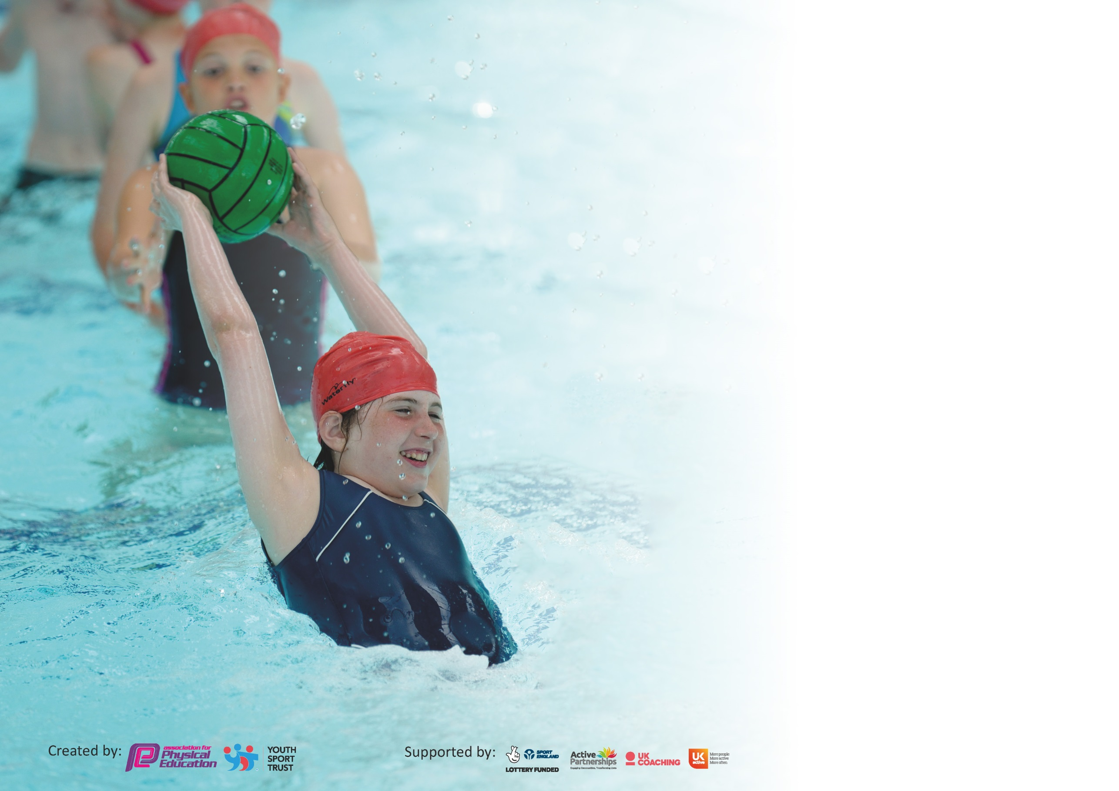

It is important that your grant is used effectively and based on school need. The [Education Inspection Framework](https://assets.publishing.service.gov.uk/government/uploads/system/uploads/attachment_data/file/843108/School_inspection_handbook_-_section_5.pdf) (Ofsted 2019 p64) makes clear there will be a focus on **‘whether leaders and those responsible for governors all understand their respective roles and perform these in a way that enhances the effectiveness of the school’**.

Under the [Quality of Education criteria](https://assets.publishing.service.gov.uk/government/uploads/system/uploads/attachment_data/file/843108/School_inspection_handbook_-_section_5.pdf) (p41) inspectors consider the extent to which schools can articulate their curriculum (INTENT), construct their curriculum (IMPLEMENTATION) and demonstrate the outcomes which result (IMPACT).

To assist schools with common transferable language this template has been developed to utilise the same three headings which should make your plans easily transferable between working documents.

Schools must use the funding to make **additional and sustainable** improvements to the quality of Physical Education, School Sport and Physical Activity (PESSPA) they offer. This means that you should

use the Primary PE and Sport Premium to:

* Develop or add to the PESSPA activities that your school already offer
* Build capacity and capability within the school to ensure that improvements made now will benefit pupils joining the school in future years

Please visit [gov.uk](https://www.gov.uk/guidance/pe-and-sport-premium-for-primary-schools) for the revised DfE guidance including the 5 key indicators across which schools should demonstrate an improvement. This document will help you to review your provision and to report your spend. DfE encourages schools to use this template as an effective way of meeting the reporting requirements of the Primary PE and Sport Premium.

We recommend you start by reflecting on the impact of current provision and reviewing the previous spend.

Schools are required to [publish details](https://www.gov.uk/guidance/what-maintained-schools-must-publish-online#pe-and-sport-premium-for-primary-schools) of how they spend this funding as well as on the impact it has on pupils’ PE and sport participation and attainment by the end of the summer term or by **31st July 2020** at the latest.

We recommend regularly updating the table and publishing it on your website throughout the year. This evidences your ongoing self-evaluation of how you are using the funding to secure maximum, sustainable impact. Final copy must be posted on your website by the end of the academic year and no later than the 31st July 2020. To see an example of how to complete the table please click [HERE](http://www.afpe.org.uk/physical-education/wp-content/uploads/afPE-Example-Template-Indicator-2018-Final.pdf).

Support for review and reflection - considering the 5 key indicators from DfE, what development needs are a priority for your setting and your pupils now and why? Use the space below to reflect on previous spend and key achievements and areas for development.

|  |  |
| --- | --- |
| Key achievements to date until July 2021: | Areas for further improvement and baseline evidence of need: |
| * KEY INDICATOR 1: In-person competitions and after school clubs have been postponed until school risk assessments allow. Prior to this, attendance numbers were increasing year on year and we hope to get back to similar levels by summer 2022. * KEY INDICATOR 2: School is now on Twitter with a general whole school page. Relevant details will be sent to HT to promote events and activities taking place around school sport and PE throughout the academic year. Pupils were coming to school ready in their PE kits on relevant days which boosted the atmosphere and activity around school. This was stopped in September 2021. * KEY INDICATOR 3: School continues to invest in the Primary PE Passport app, meaning all children will access regular P.E education throughout KS2 which can be delivered confidently by staff members. Plans include differentiation for all abilities and show a good progression of skills across year groups. * KEY INDICATOR 4: School experienced a Quidditch taster day and tournament in the academic year 2019-20 to introduce a new activity and widen the range of sports/activities our pupils could access. Response was very positive from pupils and adults. Y6s also experienced a whole day’s problem solving/teambuilding workshop which was enjoyed by all, in place of their usual residential activity week. * KEY INDIACTOR 5: Pre-covid, Sainsbury’s Survey results had shown an increasing number of children were competing in both inter and intra-school competitions and after school club attendance was also improving. We aim to get back to this level of engagement by the end of summer 2022. | * KEY INDICATIOR 1: After school clubs will be reintroduced when it is deemed safe to do so by SLT. *This commenced during Summer 2.* * KEY INDICATOR 2: Lunchtime challenges at the end of a term to continue once COVID-19 restrictions allow with the portable music system being used on the yard: behaviour/detention issues to continue to be monitored. Coordinator to discuss possibility of having a dedicated PE Twitter page run by coordinator to promote sport and PE from across school. PE kit/uniforms to be considered and supplied to families to promote PE across the school and enable pupils to attend ready in their kits on PE days. Staff kit to also be purchased to reflect best practice in PE wear across all levels. Whole school to celebrate School Sports Week 2022. * KEY INDICATOR 3: We will be investing in the Silver ESSP package again this year in order to access competitions and events for all pupils. CPD opportunities through the ESSP offered to all staff. * KEY INDICATOR 4: PE coordinator will be looking at booking further taster days for the whole school to experience. After school clubs will be reintroduced when it is deemed safe to do so by SLT. *These commenced in Summer 2.* * KEY INDIACTOR 5: Last year’s opportunities were minimal for our pupils due to covid restrictions within and outside of school. School will be re-investing in the Silver ESSP package and will begin to enter a wide range of sports to ensure opportunities appeal to as many pupils as possible. Details of competitions to be sent out by coordinator to all teaching staff. Extra opportunities for intra-year group and intra-school competitions will also be available this academic year through taster activities and staff will be asked again in their year groups to arrange end-of-unit competitions. |

|  |  |
| --- | --- |
| **Meeting national curriculum requirements for swimming and water safety.** |  |
| What percentage of your current Year 6 cohort swim competently, confidently and proficiently over a distance of at least 25 metres?  **N.B.** Even though your pupils may swim in another year please report on their attainment on leaving  primary school at the end of the summer term 2021. | 45% |
| What percentage of your current Year 6 cohort use a range of strokes effectively [for example, front crawl, backstroke and breaststroke]? | 50% |
| What percentage of your current Year 6 cohort perform safe self-rescue in different water-based situations? | 92% |
| Schools can choose to use the Primary PE and Sport Premium to provide additional provision for swimming but this must be for activity **over and above** the national curriculum requirements. Have you used it in this way? | **Yes**/No (Y6s start swimming in Summer 2) |

**Action Plan and Budget Tracking**

Capture your intended annual spend against the 5 key indicators. Clarify the success criteria and evidence of impact that you intend to measure to evaluate for pupils today and for the future.

|  |  |  |  |  |
| --- | --- | --- | --- | --- |
| **Academic Year:** 2021/22 | **Total fund allocated:** £19223 (+ £4996 carried forward from 2020-21= £24219) | **Date Updated: 21/06/2022** | |  |
| **Key indicator 1:** The engagement of all pupils in regular physical activity – Chief Medical Officer guidelines recommend that primary school pupils undertake at least 30 minutes of physical activity a day in school | | | | Percentage of total allocation: |
| £10,341.60-42.7% |
| **Intent** | **Implementation** | | **Impact** |  |
| **Your school focus should be clear what you want the pupils to know and be able to do and about**  **what they need to learn and to**  **consolidate through practice:** | **Make sure your actions to achieve are linked to your intentions:** | **Funding allocated:** | **Evidence of impact: what do pupils now know and what can they now do? What has changed?:** | **Sustainability and suggested next steps:** |
| Employment of full-time playleader (N.C) to encourage, facilitate and supervise active lunchtime activities.  Promotion of active lunchtime activities to be continued to be facilitated and led by Playleaders. Every pupil in school will have access to quality equipment and activities every day.  ~~Purchase and installation of new climbing wall to encourage active minutes during break and lunchtimes~~.  Purchase of package and equipment of ‘Now Press Play’-an active literacy tool promoting physical movement in English lessons via audio experiences. | N.C to work each lunchtime Monday-Friday. A small team of playleaders will be selected from Y3-6 to facilitate activities and develop leaderships skills.  N.C to continue organising Playleaders and keep track of equipment needed to facilitate quality lunchtime sessions. Coordinator to compile list of equipment needed.  ~~BM to purchase and facilitate the installation over the summer holidays.~~  J.R and A.S to organise a free trial in the Autumn term before purchasing. Zoom call to talk place on 17/7/22 to facilitate.  Staff training included. Class teachers to plan for regular use of the tool each term. | £3321  Purchases/replacements of equipment to facilitate activities: £520.60  ~~£4000(?) Awaiting full quote. (no longer purchasging this as of Sept 2022)~~  £2546. | From informal observations at lunchtimes, pupils engaged in a variety of daily activities. Leadership skills being developed by Playleader team.  To be reviewed in Autumn 1 2022. | PE Lead to liaise with N.C regarding replacement/additional equipment to facilitate future activities in the next academic year.  Climbing wall deemed to expensive to replace. Removal of wall to be looked into (use of second climbing wall still available ot all pupils during breaktimes) and outdoor gym equipment to possibly be purchased instead. |
| **Key indicator 2:** The profile of PESSPA being raised across the school as a tool for whole school improvement | | | | Percentage of total allocation: |
| £2985-12.3% |
| **Intent** | **Implementation** | | **Impact** |  |
| **Your school focus should be clear what you want the pupils to know and be able to do and about**  **what they need to learn and to**  **consolidate through practice:** | **Make sure your actions to achieve are linked to your intentions:** | **Funding allocated:** | **Evidence of impact: what do pupils now know and what can they now do? What has changed?:** | **Sustainability and suggested next steps:** |
| Whole school celebration of School Sports Week 2022 (SSW) with aims of:   * experience being part of a team and understand your contribution to it * demonstrate sportsmanship * have fun and enjoy yourselves!   ~~Purchasing of sports t-shirts for every pupil to be worn as part of a new PE uniform on PE days and staff PE jumpers to be worn when teaching PE. Pupils and staff to come to school again in PE kits to highlight and demonstrate the importance of PE and engaging in lessons without disruption.~~  Add to the school collection of sports based literature to engage readers in the world of sport through reading for pleasure. | PE Lead to organise a timetable for the week and include intra-class and whole school competitions in a variety of sports/activities.  PE Lead to lead an assembly to introduce the activities.  ~~PE lead and BM to order bulk set of t-shirts and school logos to be passed out to all pupils in September.~~  PE Lead and Reading Lead to agree on an Accelerated Reader set to add to school’s existing collection of books. | ~~Pupils PE tops-£1280~~  ~~Logos to iron on to clothing-£400 (no longer purchasing this as of Sept 2022)~~  Staff PE hoodies and tops-£940  Sports graphic novels Accelerated Reader set: £365 | From informal conversations and observations of pupils, pupils of all abilities enjoyed the range of activities they took part in during SSW. Archery was particularly talked about for weeks afterwards and we revisited this during our Sports Day.  SLT decision to not allow pupils coming to school in PE kits.  Staff feel able to promote a respectful use of PE uniform with their designated PE top(s) and show they are ready for their PE lessons with their classes. Expectations of pupil’s uniforms are maintained and spare kit is issued where needed.  Reluctant readers have been engaged with these new formats and have discussed their reading with the PE Lead on a variety of occasions, including some of the sports-specific vocabulary included. | PE Lead to deliver archery sessions as part of Granby Academy in 2022-23 and PE Lead will book in further experiences to celebrate SSW 2023.  To revisit summer 2023.  PE Lead to look out for new publications within the set. |

|  |  |  |  |  |
| --- | --- | --- | --- | --- |
| **Key indicator 3:** Increased confidence, knowledge and skills of all staff in teaching PE and sport | | | | Percentage of total allocation: |
| £499-2% |
| **Intent** | **Implementation** | | **Impact** |  |
| **Your school focus should be clear** | **Make sure your actions to** | **Funding** | **Evidence of impact: what do** | **Sustainability and suggested** |
| **what you want the pupils to know** | **achieve are linked to your** | **allocated:** | **pupils now know and what** | **next steps:** |
| **and be able to do and about** | **intentions:** |  | **can they now do? What has** |  |
| **what they need to learn and to** |  |  | **changed?:** |  |
| **consolidate through practice:** |  |  |  |  |
| Planning and assessment app-based tool to be renewed. Feedback from staff so far has indicated that this tool is much more convenient.  ~~Staff in Y4 and Y5 have highlighted the need for swimming training to boost confidence and quality of these sessions. Last year’s course was postponed due to COVID-19.~~ | Emails to be sent to remind staff to seek advice on app use if needed and new staff introduced via demo from PE Lead.  Yearly planning done by PE Lead (drag and drop style) ready for teachers to access their own set of plans.  ~~Places on course to be booked by office manager when COVID-19-19 regulations allow.~~ | £499  ~~£TBC~~ | A wide range of activities have continued to be available to all year groups across the terms. | Assessment by all teachers is not evident on the app. PE Lead to run a staff meeting based on this finding, re-demonstrate the app and how to assess during the lesson to reduce workload. Observations to then be organised to look for evidence of this.  Courses not running in 2021-22. PE Lead to look during the next academic year for upcoming training opportunities. |
| **Key indicator 4:** Broader experience of a range of sports and activities offered to all pupils | | | | Percentage of total allocation: |
| £7801.95-32.2% |
| **Intent** | **Implementation** | | **Impact** |  |
| **Your school focus should be clear** | **Make sure your actions to** | **Funding** | **Evidence of impact: what do** | **Sustainability and suggested** |
| **what you want the pupils to know** | **achieve are linked to your** | **allocated:** | **pupils now know and what** | **next steps:** |
| **and be able to do and about** | **intentions:** |  | **can they now do? What has** |  |
| **what they need to learn and to** |  |  | **changed?:** |  |
| **consolidate through practice:** |  |  |  |  |
| Member of staff from ESSP employed to work at Granby four days a week to engage pupils in lunchtime activities and, once restrictions are lifted, after school clubs.  Invest in extra swimming sessions for Year 6 to ensure as many pupils as possible leave primary school with the necessary skills and experiences in swimming.  All pupils in Y4,5 and 6 offered Level 1 and 2 Bikeability sessions with a member of staff from ESSP as part of our Silver package. Spare bikes and helmets borrowed from staff member and ESSP to allow pupils without the necessary equipment to participate.  Three spare bikes and helmets purchased to be kept in school to facilitate this in years to come.  Whole school participation in School Sports Week 2022. All pupils to experience a range of new and different activities throughout the week, including inter-class competitions and inter-school.  Introduction to croquet for all pupils in school as part of our Jubilee celebrations. | PE Lead to liaise with J.Jameson when after school clubs can begin to communicate with parents and arrange registers.  PE Lead to issue a parent feedback survey to scope out which clubs they would like to see offered in 2022-23.  Extra sessions to be offered to those not yet reaching the government recommendation in Summer terms.  BM to order from Halfords-March 2022  PE Lead to organise a timetable of activities for all classes to participate in.  PE Lead/BM to order sets in preparation for day’s activities. PE Lead to set up courses for pupils to engage with during the school day. | £5026  £TBC  ESSP Silver package includes bike ability sessions-£2000  Bikes and helmets £551  Croquet sets-£224.95 | Number of pupils attending after school clubs now on the rise once again following the pandemic.  From informal observations at lunchtimes, pupils engaged in a variety of daily activities.  Good level of participation across eligible year groups. Pupils can confidently and safely ride on the roads.  From informal conversations and observations of pupils, pupils of all abilities enjoyed the range of activities they took part in during SSW. Archery was particularly talked about for weeks afterwards and we revisited this during our Sports Day.  From informal conversations and observations of pupils, pupils of all abilities enjoyed their activity. There was a celebratory atmosphere during our jubilee celebrations. | After school clubs to commence in September and will run once more throughout the academic year. Places will continue to be funded by the Sports Premium to enable as many of our pupils as possible to access these opportunities.  Number of pupils participating has increased and we hope to see this continue in 2022-23 across Level 1, 2 and 3.  PE Lead to deliver archery sessions as part of Granby Academy in 2022-23 and PE Lead will book in further experiences to celebrate SSW 2023.  PE Lead to include croquet activities in our School Sports Day 2022. |

|  |  |  |  |  |
| --- | --- | --- | --- | --- |
| **Key indicator 5:** Increased participation in competitive sport | | | | Percentage of total allocation: |
| £3430-14.2% |
| **Intent** | **Implementation** | | **Impact** |  |
| **Your school focus should be clear** | **Make sure your actions to** | **Funding** | **Evidence of impact: what do** | **Sustainability and suggested** |
| **what you want the pupils to know** | **achieve are linked to your** | **allocated:** | **pupils now know and what** | **next steps:** |
| **and be able to do and about** | **intentions:** |  | **can they now do? What has** |  |
| **what they need to learn and to** |  |  | **changed?:** |  |
| **consolidate through practice:** |  |  |  |  |
| Continue to offer a wider range of competitive opportunities through our affiliation with the ESSP. Every pupil will have access to competitive sporting activities that will broaden their experiences. To be done virtually this year.  Quidditch sessions to be booked for whole school to increase experience of different non-traditional sports. Y3 will be able to experience Quidditch for the first time and Y4-6 will be able to build on skills from last time.  Whole school participation in School Sports Week 2022. All pupils to experience a range of new and different activities throughout the week, including inter-class competitions and inter-school. | Details of all competitions made available to Granby to be sent to all teaching staff.  PE Lead to book on to events as requested.  Quidditch booked for June 2023.  PE Lead to organise a timetable of activities for all classes to participate in. | ESSP Silver Package: £2000  £1430 | Low impact this year. Very few competitions entered into due to PE Lead being on maternity leave.  From informal conversations and observations of pupils, pupils of all abilities enjoyed the range of activities they took part in during SSW. Archery was particularly talked about for weeks afterwards and we revisited this during our Sports Day. | PE Lead, once back in school, to book onto events through the ESSP throughout 2022-23.  To be evaluated in summer 2023.  PE Lead to deliver archery sessions as part of Granby Academy in 2022-23 and PE Lead will book in further experiences to celebrate SSW 2023. |

|  |  |
| --- | --- |
| Total spend for 2021-2022 academic year: £23,057.55 (£5680 earmarked for invoices due after summer)  Totals in black font reflect spending before April 2022.  Totals in orange font reflect spending after start of new tax year April 2022. | |
| Signed off by | |
| Head Teacher: |  |
| Date: |  |
| Subject Leader: | Miss J Robinson |
| Date: | 12/12/2022 |
| Governor: |  |
| Date: |  |